TEAM ID - PNT2022TMID38058

# Import and unzip the dataset



Mounted at /content/drive

#unzip the downloaded dataset



!unzip '/content/drive/MyDrive/damage vehicle.zip'

Archive: /content/drive/MyDrive/damage vehicle.zip creating: damage vehicle/

creating: damage vehicle/body/ creating: damage vehicle/body/training/

creating: damage vehicle/body/training/00-front/ inflating: damage vehicle/body/training/00-front/0001.jpeg inflating: damage vehicle/body/training/00-front/0002.JPEG inflating: damage vehicle/body/training/00-front/0003.JPEG inflating: damage vehicle/body/training/00-front/0004.JPEG inflating: damage vehicle/body/training/00-front/0005.JPEG inflating: damage vehicle/body/training/00-front/0006.JPEG inflating: damage vehicle/body/training/00-front/0007.JPEG inflating: damage vehicle/body/training/00-front/0008.jpeg inflating: damage vehicle/body/training/00-front/0009.JPEG inflating: damage vehicle/body/training/00-front/0010.JPEG inflating: damage vehicle/body/training/00-front/0011.JPEG inflating: damage vehicle/body/training/00-front/0012.jpeg inflating: damage vehicle/body/training/00-front/0013.JPEG inflating: damage vehicle/body/training/00-front/0014.JPEG inflating: damage vehicle/body/training/00-front/0015.JPEG inflating: damage vehicle/body/training/00-front/0016.JPEG inflating: damage vehicle/body/training/00-front/0017.JPEG inflating: damage vehicle/body/training/00-front/0018.JPEG inflating: damage vehicle/body/training/00-front/0019.JPEG inflating: damage vehicle/body/training/00-front/0020.jpeg inflating: damage vehicle/body/training/00-front/0021.JPEG inflating: damage vehicle/body/training/00-front/0022.JPEG inflating: damage vehicle/body/training/00-front/0023.JPEG inflating: damage vehicle/body/training/00-front/0024.JPEG inflating: damage vehicle/body/training/00-front/0025.jpeg inflating: damage vehicle/body/training/00-front/0026.JPEG inflating: damage vehicle/body/training/00-front/0027.JPEG inflating: damage vehicle/body/training/00-front/0028.JPEG inflating: damage vehicle/body/training/00-front/0029.JPEG inflating: damage vehicle/body/training/00-front/0030.JPEG inflating: damage vehicle/body/training/00-front/0031.JPEG inflating: damage vehicle/body/training/00-front/0032.JPEG inflating: damage vehicle/body/training/00-front/0033.JPEG inflating: damage vehicle/body/training/00-front/0034.JPEG inflating: damage vehicle/body/training/00-front/0035.jpeg inflating: damage vehicle/body/training/00-front/0036.JPEG inflating: damage vehicle/body/training/00-front/0037.JPEG inflating: damage vehicle/body/training/00-front/0038.JPEG inflating: damage vehicle/body/training/00-front/0039.JPEG inflating: damage vehicle/body/training/00-front/0040.JPEG inflating: damage vehicle/body/training/00-front/0041.JPEG inflating: damage vehicle/body/training/00-front/0042.JPEG inflating: damage vehicle/body/training/00-front/0043.JPEG inflating: damage vehicle/body/training/00-front/0044.JPEG inflating: damage vehicle/body/training/00-front/0045.JPEG inflating: damage vehicle/body/training/00-front/0046.jpeg inflating: damage vehicle/body/training/00-front/0047.JPEG inflating: damage vehicle/body/training/00-front/0048.JPEG inflating: damage vehicle/body/training/00-front/0049.JPEG inflating: damage vehicle/body/training/00-front/0050.JPEG inflating: damage vehicle/body/training/00-front/0051.JPEG inflating: damage vehicle/body/training/00-front/0052.JPEG inflating: damage vehicle/body/training/00-front/0053.JPEG

# Image Preprocessing

1. **Import The ImageDataGenerator Library**





1. **Configure ImageDataGenerator Class**

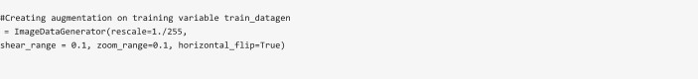



1. **Apply ImageDataGenerator Functionality To Trainset And Testset**

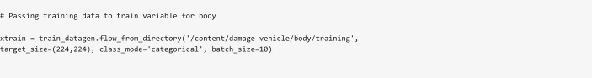

Found 979 images belonging to 3 classes.

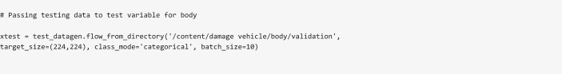

Found 171 images belonging to 3 classes.

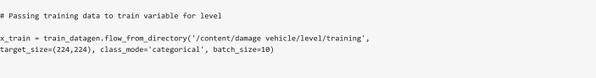

Found 979 images belonging to 3 classes.

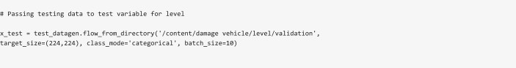

Found 171 images belonging to 3 classes.

# Model Building

**For Body**

1. **Importing The Model Building Libraries**

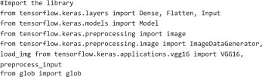

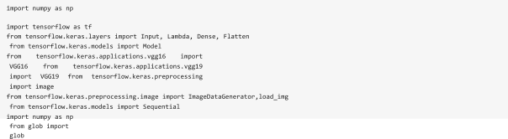

1. **Loading The Model**





Downloading data from [https://storage.googleapis.com/tensorflow/keras-applications/vgg16/vgg16_weights_tf_dim_ordering_tf_ke](https://storage.googleapis.com/tensorflow/keras-applications/vgg16/vgg16_weights_tf_dim_ordering_tf_kernels_notop.h5) 58889256/58889256 [==============================] - 3s 0us/step

1. **Adding Flatten Layer**







['/content/damage vehicle/body/training/00-front', '/content/damage vehicle/body/training/01-rear', '/content/damage vehicle/body/training/02-side']





3

1. **Adding Output Layer**



1. **Creating A Model Object**





Model: "model" Layer (type)

Output Shape

Param #

============================ ========================= ============

|  |  |  |
| --- | --- | --- |
| input_1 (InputLayer) | [(None, 224, 224, 3)] | 0 |
| block1_conv1 (Conv2D) | (None, 224, 224, 64) | 1792 |
| block1_conv2 (Conv2D) | (None, 224, 224, 64) | 36928 |
| block1_pool (MaxPooling2D) | (None, 112, 112, 64) | 0 |
| block2_conv1 (Conv2D) | (None, 112, 112, 128) | 73856 |
| block2_conv2 (Conv2D) | (None, 112, 112, 128) | 147584 |

|  |  |  |  |  |  |
| --- | --- | --- | --- | --- | --- |
| block2_pool (MaxPooling2D) | (None, | 56, | 56, | 128) | 0 |
| block3_conv1 (Conv2D) | (None, | 56, | 56, | 256) | 295168 |
| block3_conv2 (Conv2D) | (None, | 56, | 56, | 256) | 590080 |
| block3_conv3 (Conv2D) | (None, | 56, | 56, | 256) | 590080 |
| block3_pool (MaxPooling2D) | (None, | 28, | 28, | 256) | 0 |
| block4_conv1 (Conv2D) | (None, | 28, | 28, | 512) | 1180160 |
| block4_conv2 (Conv2D) | (None, | 28, | 28, | 512) | 2359808 |
| block4_conv3 (Conv2D) | (None, | 28, | 28, | 512) | 2359808 |
| block4_pool (MaxPooling2D) | (None, | 14, | 14, | 512) | 0 |
| block5_conv1 (Conv2D) | (None, | 14, | 14, | 512) | 2359808 |
| block5_conv2 (Conv2D) | (None, | 14, | 14, | 512) | 2359808 |
| block5_conv3 (Conv2D) | (None, | 14, | 14, | 512) | 2359808 |

block5_pool (MaxPooling2D) (None, 7, 7, 512) 0

|  |  |  |
| --- | --- | --- |
| flatten (Flatten) | (None, 25088) | 0 |
| dense (Dense) | (None, 3) | 75267 |

=================================================================



Total params: 14,789,955

Trainable params: 75,267

Non-trainable params: 14,714,688



1. **Configure The Learning Process**

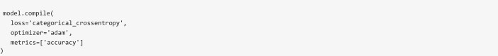

1. **Train The Model**

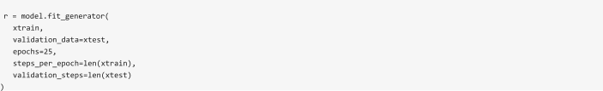

/usr/local/lib/python3.7/dist-packages/ipykernel_launcher.py:6: UserWarning: `Model.fit_generator` is deprecated and will be

|  |  |  |  |  |  |  |  |  |
| --- | --- | --- | --- | --- | --- | --- | --- | --- |
| Epoch | 1/25 |  | | | | | | |
| 98/98 | [==============================] | - 23s | | 146ms/step | - loss: | 1.2077 | - accuracy: | 0.5465 - val_loss: 1.2900 - val_accuracy: |
| Epoch | 2/25 |  | |  |  |  |  |  |
| 98/98 | [==============================] | - 13s | | 128ms/step | - loss: | 0.8364 | - accuracy: | 0.7028 - val_loss: 0.8665 - val_accuracy: |
| Epoch | 3/25 |  | |  |  |  |  |  |
| 98/98 | [==============================] | - 13s | | 128ms/step | - loss: | 0.5293 | - accuracy: | 0.7998 - val_loss: 1.3260 - val_accuracy: |
| Epoch | 4/25 |  | |  |  |  |  |  |
| 98/98 | [==============================] | - 12s | | 127ms/step | - loss: | 0.3978 | - accuracy: | 0.8611 - val_loss: 0.9842 - val_accuracy: |
| Epoch | 5/25 |  | |  |  |  |  |  |
| 98/98 | [==============================] | - 12s | | 127ms/step | - loss: | 0.2783 | - accuracy: | 0.9030 - val_loss: 0.9397 - val_accuracy: |
| Epoch | 6/25 |  | |  |  |  |  |  |
| 98/98 | [==============================] | - 13s | | 128ms/step | - loss: | 0.2690 | - accuracy: | 0.9070 - val_loss: 0.9892 - val_accuracy: |
| Epoch | 7/25 |  | |  |  |  |  |  |
| 98/98 | [==============================] | - 12s | | 127ms/step | - loss: | 0.1788 | - accuracy: | 0.9448 - val_loss: 1.0052 - val_accuracy: |
| Epoch | 8/25 |  | |  |  |  |  |  |
| 98/98 | [==============================] | - 13s | | 129ms/step | - loss: | 0.1671 | - accuracy: | 0.9469 - val_loss: 1.1693 - val_accuracy: |
| Epoch | 9/25 |  | |  |  |  |  |  |
| 98/98 | [==============================] | - 13s | | 129ms/step | - loss: | 0.1277 | - accuracy: | 0.9561 - val_loss: 1.0058 - val_accuracy: |
| Epoch | 10/25 |  |  |  |  |  |  |  |
| 98/98 | [==============================] | - | 13s | 128ms/step | - loss: | 0.1184 | - accuracy: | 0.9591 - val_loss: 1.0620 - val_accuracy: |
| Epoch | 11/25 |  |  |  |  |  |  |  |
| 98/98 | [==============================] | - | 13s | 130ms/step | - loss: | 0.0963 | - accuracy: | 0.9745 - val_loss: 1.1219 - val_accuracy: |
| Epoch | 12/25 |  |  |  |  |  |  |  |

98/98

Epoch 98/98

Epoch

98/98

Epoch 98/98

Epoch 98/98

[==============================] 13/25

[==============================] 14/25

|  |  |  |  |  |  |  |  |
| --- | --- | --- | --- | --- | --- | --- | --- |
| - 13s | 129ms/step | - loss: | 0.0857 | - accuracy: | 0.9765 - val_loss: 1.0284 - val_accuracy: | | |
| - 13s | 129ms/step | - loss: | 0.0582 | - accuracy: | 0.9837 - val_loss: 1.1153 - val_accuracy: | | |
| - 13s | 129ms/step | - loss: | 0.0688 | - accuracy: | 0.9877 - val_loss: 1.1033 - val_accuracy: | | |
| - 13s | 131ms/step | - loss: | 0.0709 | - accuracy: | 0.9867 - val_loss: 1.0730 - val_accuracy: | | |
| - 13s | 128ms/step | - loss: | 0.0895 | - accuracy: | 0.9775 - val_loss: 1.1225 - val_accuracy: | | |
| - 13s | 129ms/step | - loss: | 0.0609 | - accuracy: | 0.9918 - val_loss: 1.2937 - val_accuracy: | | |
| - 13s | 128ms/step | - loss: | 0.0998 | - accuracy: | 0.9714 - val_loss: 1.1754 - val_accuracy: | | |
| - 13s | 128ms/step | - loss: | 0.0728 | - accuracy: | 0.9847 - val_loss: 1.5074 - val_accuracy: | | |
| - 13s | 129ms/step | - loss: | 0.0972 | - accuracy: | 0.9714 - val_loss: 1.4684 - val_accuracy: | | |
| - 13s | 131ms/step | - loss: | 0.0404 | - accuracy: | 0.9908 - val_loss: 1.4215 - val_accuracy: | | |
| - 13s | 131ms/step | - loss: | 0.0854 | - accuracy: | 0.9867 - val_loss: 1.4772 - val_accuracy: | | |
| - 13s | 128ms/step | - loss: | 0.0399 | - accuracy: | 0.9918 - val_loss: 1.4306 - val_accuracy: | | |
| - 13s | 129ms/step | - loss: | 0.0400 | - accuracy: | 0.9908 | - val_loss: | 1.4562 - val_accuracy: |
| - 13s | 129ms/step | - loss: | 0.1692 | - accuracy: | 0.9387 | - val_loss: | 1.6805 - val_accuracy: |

[==============================] 15/25 [==============================]

16/25 [==============================]

Epoch 17/25

98/98

Epoch 98/98

Epoch 98/98

[==============================] 18/25 [==============================]

19/25 [==============================]

Epoch 20/25

98/98

Epoch 98/98

Epoch 98/98

Epoch 98/98

[==============================] 21/25

[==============================] 22/25 [==============================]

23/25 [==============================]

Epoch 24/25

98/98

Epoch 98/98

[==============================] 25/25 [==============================]

 

1. **Save The Model**



1. **Test The Model**

from tensorflow.keras.models import load_model import cv2

from skimage.transform import resize

model = load_model('/content/damage vehicle/Model/body.h5')

def detect(frame):

img = cv2.resize(frame,(224,224))

img = cv2.cvtColor(img,cv2.COLOR_BGR2RGB)

if(np.max(img)>1):

img = img/255.0

img = np.array([img]) prediction

= model.predict(img) label = ["front","rear","side"]

preds = label[np.argmax(prediction)]

return preds import numpy as np

data = "/content/damage vehicle/body/training/00 -front/0002.JPEG" image = cv2.imread(data)

print(detect(image))

1/1 [==============================] - 0s 148ms/step

front

# Model Building For Level



1. **Importing The Model Building Libraries**

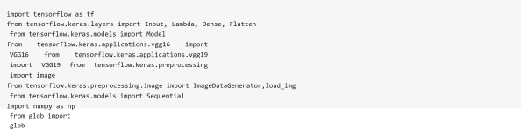

1. **Loading The Model**





1. **Adding Flatten Layer**







['/content/damage vehicle/level/training/03-severe', '/content/damage vehicle/level/training/02-moderate', '/content/damage vehicle/level/training/01-minor']





3

1. **Adding Output Layer**



1. **Creating A Model Object**





Model: "model_1"

Layer (type)

Output Shape

Param #

============================ ========================= ============

|  |  |  |
| --- | --- | --- |
| input_2 (InputLayer) | [(None, 224, 224, 3)] | 0 |
| block1_conv1 (Conv2D) | (None, 224, 224, 64) | 1792 |
| block1_conv2 (Conv2D) | (None, 224, 224, 64) | 36928 |
| block1_pool (MaxPooling2D) | (None, 112, 112, 64) | 0 |
| block2_conv1 (Conv2D) | (None, 112, 112, 128) | 73856 |
| block2_conv2 (Conv2D) | (None, 112, 112, 128) | 147584 |
| block2_pool (MaxPooling2D) | (None, 56, 56, 128) | 0 |
| block3_conv1 (Conv2D) | (None, 56, 56, 256) | 295168 |

|  |  |  |  |  |  |
| --- | --- | --- | --- | --- | --- |
| block3_conv2 (Conv2D) | (None, | 56, | 56, | 256) | 590080 |
| block3_conv3 (Conv2D) | (None, | 56, | 56, | 256) | 590080 |
| block3_pool (MaxPooling2D) | (None, | 28, | 28, | 256) | 0 |
| block4_conv1 (Conv2D) | (None, | 28, | 28, | 512) | 1180160 |
| block4_conv2 (Conv2D) | (None, | 28, | 28, | 512) | 2359808 |
| block4_conv3 (Conv2D) | (None, | 28, | 28, | 512) | 2359808 |
| block4_pool (MaxPooling2D) | (None, | 14, | 14, | 512) | 0 |
| block5_conv1 (Conv2D) | (None, | 14, | 14, | 512) | 2359808 |
| block5_conv2 (Conv2D) | (None, | 14, | 14, | 512) | 2359808 |
| block5_conv3 (Conv2D) | (None, | 14, | 14, | 512) | 2359808 |

block5_pool (MaxPooling2D) (None, 7, 7, 512) 0

|  |  |  |
| --- | --- | --- |
| flatten_1 (Flatten) | (None, 25088) | 0 |
| dense_1 (Dense) | (None, 3) | 75267 |

=================================================================



Total params: 14,789,955

Trainable params: 75,267

Non-trainable params: 14,714,688

1. **Configure The Learning Process**



1. 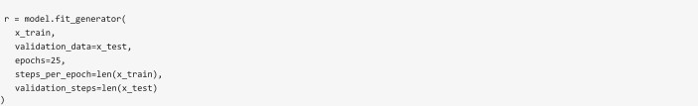**Train The Model**

/usr/local/lib/python3.7/dist-packages/ipykernel_launcher.py:6: UserWarning: `Model.fit_generator` is deprecated and will be Epoch 1/25

98/98

Epoch 98/98

Epoch 98/98

Epoch 98/98

[==============================] 2/25

[==============================] 3/25 [==============================]

|  |  |  |  |  |  |
| --- | --- | --- | --- | --- | --- |
| - 14s | 133ms/step | - loss: | 1.1629 | - accuracy: | 0.5495 - val_loss: 1.1559 - val_accuracy: |
| - 13s | 130ms/step | - loss: | 0.7157 | - accuracy: | 0.7089 - val_loss: 0.9643 - val_accuracy: |
| - 13s | 130ms/step | - loss: | 0.4978 | - accuracy: | 0.8161 - val_loss: 1.5663 - val_accuracy: |
| - 13s | 128ms/step | - loss: | 0.5277 | - accuracy: | 0.7865 - val_loss: 1.6003 - val_accuracy: |
| - 13s | 128ms/step | - loss: | 0.3763 | - accuracy: | 0.8468 - val_loss: 1.1925 - val_accuracy: |
| - 13s | 128ms/step | - loss: | 0.2445 | - accuracy: | 0.9203 - val_loss: 1.0354 - val_accuracy: |
| - 13s | 128ms/step | - loss: | 0.1902 | - accuracy: | 0.9346 - val_loss: 1.2155 - val_accuracy: |
| - 13s | 128ms/step | - loss: | 0.1327 | - accuracy: | 0.9571 - val_loss: 1.0902 - val_accuracy: |
| - 13s | 127ms/step | - loss: | 0.1206 | - accuracy: | 0.9540 - val_loss: 1.1282 - val_accuracy: |
| - 13s | 128ms/step | - loss: | 0.1181 | - accuracy: | 0.9591 - val_loss: 1.1311 - val_accuracy: |
| - 13s | 128ms/step | - loss: | 0.0910 | - accuracy: | 0.9765 - val_loss: 1.1538 - val_accuracy: |
| - 12s | 127ms/step | - loss: | 0.0813 | - accuracy: | 0.9806 - val_loss: 1.2209 - val_accuracy: |
| - 13s | 128ms/step | - loss: | 0.0603 | - accuracy: | 0.9857 - val_loss: 1.2545 - val_accuracy: |

4/25 [==============================]

Epoch 5/25

98/98

Epoch 98/98

Epoch 98/98

[==============================] 6/25

[==============================] 7/25

[==============================]

Epoch 8/25

98/98

Epoch 98/98

Epoch

98/98

Epoch 98/98

[==============================] 9/25

[==============================] 10/25

[==============================] 11/25 [==============================]

Epoch 12/25

98/98

Epoch 98/98

[==============================]

13/25 [==============================]

Epoch 14/25

98/98

Epoch 98/98

Epoch

98/98

Epoch 98/98

Epoch 98/98

[==============================] 15/25

[==============================] 16/25

|  |  |  |  |  |  |  |  |  |
| --- | --- | --- | --- | --- | --- | --- | --- | --- |
| - 12s | | 127ms/step | - loss: | 0.0474 | - accuracy: | 0.9949 - val_loss: 1.1609 - val_accuracy: | | |
| - 13s | | 129ms/step | - loss: | 0.0366 | - accuracy: | 0.9959 - val_loss: 1.1688 - val_accuracy: | | |
| - 13s | | 128ms/step | - loss: | 0.0493 | - accuracy: | 0.9888 - val_loss: 1.1850 - val_accuracy: | | |
| - 13s | | 128ms/step | - loss: | 0.0320 | - accuracy: | 0.9939 - val_loss: 1.1884 - val_accuracy: | | |
| - 13s | | 129ms/step | - loss: | 0.0363 | - accuracy: | 0.9939 - val_loss: 1.2897 - val_accuracy: | | |
| - 13s | | 128ms/step | - loss: | 0.0298 | - accuracy: | 0.9949 - val_loss: 1.2499 - val_accuracy: | | |
| - 13s | | 130ms/step | - loss: | 0.0250 | - accuracy: | 0.9980 - val_loss: 1.2801 - val_accuracy: | | |
| - 13s | | 129ms/step | - loss: | 0.0329 | - accuracy: | 0.9959 - val_loss: 1.2366 - val_accuracy: | | |
| - 13s | | 128ms/step | - loss: | 0.0170 | - accuracy: | 1.0000 - val_loss: 1.2901 - val_accuracy: | | |
| - 13s | | 130ms/step | - loss: | 0.0216 | - accuracy: | 1.0000 - val_loss: 1.2697 - val_accuracy: | | |
| - | 13s | 128ms/step | - loss: | 0.0365 | - accuracy: | 0.9908 | - val_loss: | 1.4214 - val_accuracy: |
| - | 13s | 129ms/step | - loss: | 0.0380 | - accuracy: | 0.9939 | - val_loss: | 1.4219 - val_accuracy: |

[==============================] 17/25 [==============================]

18/25 [==============================]

Epoch 19/25

98/98

Epoch 98/98

Epoch 98/98

[==============================] 20/25 [==============================]

21/25 [==============================]

Epoch 22/25

98/98

Epoch 98/98

Epoch 98/98

Epoch 98/98

[==============================] 23/25

[==============================] 24/25 [==============================]

25/25 [==============================]

 

1. **Save The Model**



1. **Test The Model**

|  |
| --- |
| from tensorflow.keras.models import load_model import cv2  from skimage.transform import resize |
| model = load_model('/content/damage vehicle/Model/level.h5') |
| def detect(frame):  img = cv2.resize(frame,(224,224))  img = cv2.cvtColor(img,cv2.COLOR_BGR2RGB)  if(np.max(img)>1):  img = img/255.0  img = np.array([img]) prediction  = model.predict(img)  label = ["minor","moderate","severe"] preds = label[np.argmax(prediction)] return preds |
| import numpy as np |
| data = "/content/damage vehicle/level/validation/01 -minor/0005.JPEG" image = cv2.imread(data)  print(detect(image)) |

1/1 [==============================] - 0s 142ms/step

minor



[Colab paid products](https://colab.research.google.com/signup?utm_source=footer&utm_medium=link&utm_campaign=footer_links) - [Cancel contracts here](https://colab.research.google.com/cancel-subscription)

